E-COMMERCE APP FOR LUXE HAVEN

A PROJECT REPORT
(22ITP61-Project Work)

Submitted by

ASWATH SIVA K M (23ITR010)

ASWIGA P (23ITR011)
in partial fulfilment of the requirements
for the award of the degree
of

BACHELOR OF TECHNOLOGY IN

INFORMATION TECHNOLOGY

DEPARTMENT OF INFORMATION TECHNOLOGY


(Autonomous)
PERUNDURAI ERODE – 638 060

MARCH 2026

DEPARTMENT OF INFORMATION TECHNOLOGY KONGU ENGINEERING COLLEGE
(Autonomous)

PERUNDURAI ERODE – 638060

MARCH 2026

BONAFIDE CERTIFICATE

This is to certify that the Project report entitled “ E-COMMERCE APP LUXE HAVEN” is the Bonafide record of project work done by ASWATH SIVA K M (23ITR010) and ASWIGA P (23ITR011) in partial fulfilment of the requirements for the award of the Degree of Bachelor of Technology in INFORMATION TECHNOLOGY of Anna University Chennai during the year 2025 - 2026.

SUPERVISOR HEAD OF THE DEPARTMENT
Date: (Signature with seal)

Submitted for the end semester viva voce examination held on .

INTERNAL EXAMINER EXTERNAL EXAMINER

DEPARTMENT OF INFORMATION TECHNOLOGY KONGU ENGINEERING COLLEGE
(Autonomous)
PERUNDURAI ERODE – 638060
MARCH 2026

DECLARATION

We affirm that the Project Report titled “ E-COMMERCE APP LUXE HAVEN ” being submitted in partial fulfilment of the requirements for the award of Bachelor of Technology is the original work carried out by us. It has not formed the part of any other project report or dissertation on the basis of which a degree or award was conferred on an earlier occasion on this or any other candidate.

ASWATH SIVA K M
(23ITR010)

ASWIGA P
(23ITR011)

Date:

I certify that the declaration made by the above candidates is true to the best of my knowledge.

Date: Name and Signature of the Supervisor with seal

ACKNOWLEDGEMENT

First and foremost, we acknowledge the abundant grace and presence of Almighty throughout different phases of the project and its successful completion.

We express our gratefulness to Correspondent THIRU. E. R. K. Krishnan, M.Com. and all the trust members of Kongu Vellalar Institute of Technology Trust for providing all the necessary facilities to complete the project successfully.

We express our deep sense of gratitude to our beloved Principal Dr.R.Parameshwaran M.E.,Ph.D., for providing us an opportunity to complete the project.

We express our gratitude to Dr. S. Anandamurugan M.E.,Ph.D., Head of the Department, Department of Information Technology for his valuable suggestions.

We are thankful to our Project Coordinators Dr.E.M.Roopa Devi M.E,Ph.D.,
Ms.S.Sujitha M.Tech and G.Sasikala M.E., for their valuable guidance and support.

We are highly indebted to Mr.A.P.Ponselvakumar ME., Department of Information Technology for his valuable supervision and advice for the fruitful completion of the project.

We are thankful to the faculty members of the Department of Information Technology for their valuable guidance and support.

We are obliged to thank Mr.S.HARISHWA, Owner of (LUXE HAVEN) for supporting us through the various development phases of the project with atmost trust.

ABSTRACT
Luxe Haven is a cutting-edge e-commerce mobile application designed to transform the luxury retail landscape by delivering an unparalleled online shopping experience. The platform empowers customers to effortlessly browse premium products, curate wishlists, manage shopping carts, and complete secure transactions, while providing businesses with sophisticated tools for inventory management, order processing, and customer engagement. Through this digital solution, Luxe Haven bridges the divide between traditional luxury retail and modern e-commerce, enabling seamless 24/7 access to high-end fashion and lifestyle products.

A key highlight of the system is its robust Razorpay payment integration, ensuring swift, secure, and reliable financial transactions that build customer trust. The application features a comprehensive admin dashboard offering real-time insights into inventory levels, order statuses, sales analytics, and customer behavior. This dual-benefit approach enhances the customer journey with intuitive navigation and personalized experiences, while equipping businesses with data-driven tools to optimize operations and drive revenue growth.

Built on a scalable architecture, Luxe Haven is poised for future expansions including multi-vendor support, advanced analytics, loyalty programs, and AI-powered recommendations. These planned enhancements will further amplify the platform's value, positioning it as an indispensable tool for luxury brands seeking sustainable growth.

In essence, Luxe Haven represents a forward-thinking approach to luxury e-commerce, blending elegant design with powerful functionality. By harnessing mobile technology, the application not only delivers immediate operational efficiencies and enhanced customer satisfaction but also lays the groundwork for long-term digital excellence in the competitive luxury marketplace. This project exemplifies how traditional retail sectors can embrace innovation to create exceptional shopping experiences and achieve lasting success in the digital era.

TABLE OF CONTENTS

CHAPTER No. TITLE PAGE No.

ABSTRACT | iv
LIST OF FIGURES | viii
LIST OF ABBREVIATIONS | ix
1 INTRODUCTION | 1
1.1 OVERVIEW | 1
1.2 OBJECTIVE | 1
2 SYSTEM SPECIFICATION | 2
2.1 HARDWARE REQUIREMENTS | 2
2.2 SOFTWARE REQUIREMENTS | 2
2.3 SOFTWARE DESCRIPTION | 3
2.3.1 Visual Studio Code | 3
2.3.2 NodeJS | 3
2.3.3 MongoDB | 5
2.3.4 React | 5
3 SYSTEM DESIGN | 7
3.1 USE CASE DIAGRAM | 7
3.2 CLASS DIAGRAM | 8
3.3 SEQUENCE DIAGRAM | 9
3.4 ACTIVITY DIAGRAM | 10
3.5 DATABASE DESIGN | 11

  - MODULES DESCRIPTION 13
    - User Authentication Module 13
    - Product Management Module 13
    - Product Browsing and Search Module 13
    - Cart and Order Placement Module 13
    - Admin Dashboard Module 14
- TESTING 15
  - SYSTEM TESTING 15
  - UNIT TESTING 15
  - MODULE TESTING 15
  - INTEGRATION TESTING 16
  - VALIDATION TESTING 16
- RESULTS & DISCUSSIONS 17
- CONCLUSION 20
APPENDIX 1- CODING 21
APPENDIX 2- SNAPSHOTS 40
REFERENCES 45

LIST OF FIGURES

FIGURE No. | FIGURE NAME | PAGE No.
3.1 | USE CASE DIAGRAM | 7
3.2 | CLASS DIAGRAM | 8
3.3 | SEQUENCE DIAGRAM | 9
3.4 | ACTIVITY DIAGRAM | 10
A2.1 | HOME PAGE | 40
A2.2 | REGISTER SCREEN | 40
A2.3 | LOGIN SCREEN | 41
A2.4 | USER DASHBOARD | 41
A2.5 | PRODUCT LISTING | 42
A2.6 | PRODUCT DETAILS | 42
A2.7 | SHIPPING DETAILS FOR USER | 43
A2.8 | USERS ORDERS | 43
A2.9 | USER PROFILE PAGE | 44
A2.10 | SELLER-ADD PRODUCT | 44

LIST OF ABBREVIATIONS

AI - Artificial Intelligence
AJAX - Asynchronous JavaScript and XML
API - Application Programming Interface
CSS - Cascading Style Sheets
HTML - HyperText Markup Language
HTTP - HyperText Transfer Protocol
ID - Identification
I/O - Input/Output
JS - JavaScript
JSON - JavaScript Object Notation
JSX - JavaScript XML
JWT - JSON Web Token
QR - Quick Response
URL - Uniform Resource LocatorQR – Quick Response
URL - Uniform Resource Locator

CHAPTER 1

INTRODUCTION

1.1 OVERVIEW

The escalating need for digital transformation in the retail industry has underscored the importance of adopting agile and scalable solutions to manage modern commerce operations. This project centers on creating a mobile-based e-commerce application tailored for Luxe Haven, designed to optimize product sales, inventory management, and customer interactions. The platform empowers users to explore luxury fashion and lifestyle products, manage wishlists, place orders, and execute secure payments via an integrated gateway, while enabling administrators to oversee stock levels and track transactions in real time. Through the automation of core business processes, this solution diminishes manual efforts, curtails inaccuracies, and boosts overall operational productivity. It establishes a foundation for sustained growth, superior customer service, and seamless integration with cutting-edge retail technologies.

1.2 OBJECTIVE

- To create a robust e-commerce mobile application for Luxe Haven that facilitates streamlined product sales, inventory oversight, and customer engagement.
- To incorporate real-time product updates, secure payment processing (via Razorpay), and an intuitive user interface to elevate the shopping journey.
- To enhance business performance by automating transactions and delivering a reliable, secure environment for both customers and administrators.

CHAPTER 2

SYSTEM SPECIFICATION

2.1 HARDWARE REQUIREMENTS

Processor : | Intel Pentium
Processor Speed : | 250MHz to 667MHz
RAM : | 4GB RAM
Hard Disk : | 256GB
Keyboard : | Standard 104 enhanced
Mouse :  2.2 SOFTWARE REQUIREMENTS | Local PS/2
Platform : | Visual Studio Code
Server-Side Script : | NodeJS
Operating System : | Windows, macOS, or Linux
Backend : | MongoDB
Library : | React Native

2.3 SOFTWARE DESCRIPTION

2.3.1 Visual Studio Code

Visual Studio Code is a versatile and user-friendly code editor used by developers worldwide. It supports a wide range of programming languages and frameworks, including JavaScript, React, and Node.js. For this project, VS Code provides a convenient environment for writing, editing, and debugging code related to server-side scripting with Node.js, as well as client-side scripting with React.js. Its built-in terminal and debugging tools streamline the development process, while its customizable features allow developers to tailor the editor to their specific needs, enhancing productivity and efficiency throughout the project lifecycle.

• ES6+ React/Vite Snippets:
ES6 React/Vite snippets provide code templates designed to simplify and accelerate the development process for building applications with React, React Router, and Axios in the Luxe-Haven platform. These snippets utilize the powerful features introduced in ES6, allowing developers to quickly scaffold common patterns like React functional components with hooks, custom hooks for API calls, form components, and page layouts. By incorporating ES6 syntax, such as arrow functions, destructuring, template literals, and modules, these snippets make it easier to write clean and concise code. With ES6 snippets, developers can efficiently generate standardized code structures for components like ProductCard, CartItem, OrderHistory, and UserProfile, promoting consistency and reducing the chance of errors, cutting down on boilerplate code. This collection of snippets supports the creation of web applications with reusable UI components, state management through React hooks, API integration patterns with Axios for backend communication, and navigation flows with React Router for multi-page experiences. Whether developing user interfaces for buyers and sellers, managing cart and order states, or integrating with backend APIs via Express.js, these ES6 snippets help developers stay focused on creating features and solving problems instead of repeating boilerplate setup. The snippets accelerate typical e-commerce workflows like product listing, checkout flows, seller dashboards, and admin panels, enabling rapid prototyping and consistent code quality across the Luxe-Haven platform.

2.3.2 NodeJS

Node.js is a powerful server-side JavaScript runtime environment commonly used for building scalable and efficient web applications. In our project, Node.js serves as
the server- side scripting language, handling tasks such as routing, handling HTTP requests, and interacting with the MongoDB database. Its event-driven architecture and non- blocking I/O operations make it well-suited for handling concurrent connections and processing requests efficiently. With its vast ecosystem of libraries and frameworks, Node.js allows for rapid development and deployment of server-side applications. Additionally, its compatibility with Visual Studio Code provides a seamless development experience, enabling developers to write, test, and debug server-side code effectively within a unified environment. Overall, Node.js plays a crucial role in this project by powering the backend infrastructure and facilitating the seamless integration of frontend and backend components.

- Bcryptjs

Bcryptjs is a library used for hashing passwords in JavaScript. It provides a
secure way to hash passwords before storing them in a database or comparing them during authentication processes. By using bcryptjs, developers can ensure that user passwords are encrypted and protected against common security threats like brute force attacks and rainbow table attacks.

- Express

Express is a minimalist web application framework for Node.js. It provides a
robust set of features for building web servers and APIs, including routing, middleware support, template engines, and HTTP utilities. With its simple and flexible design, Express enables developers to quickly create scalable and maintainable web applications
.
- Jsonwebtoken

JSON Web Token is an open standard (RFC 7519) that defines a compact and
self-contained way for securely transmitting information between parties as a JSON object. JWTs are commonly used for authentication and authorization in web applications. The jsonwebtoken library provides utilities for generating, parsing, and verifying JWTs, making it easy to implement token-based authentication and authorization systems.

2.3.3 MongoDB

MongoDB is a flexible and scalable NoSQL database platform ideal for managing complex data structures, making it invaluable for our project's e-commerce website. With MongoDB's document-oriented architecture, we can efficiently store and manage diverse types of data relevant to our e-commerce platform, such as user information, appointment details, and messages. Its schema-less nature allows for dynamic and evolving data models, accommodating the dynamic nature of e-commerce data. For this project, MongoDB's scalability is crucial as it can seamlessly handle increasing volumes of data and traffic, ensuring optimal performance even during peak usage periods. This scalability ensures that the website remains responsive and can accommodate growth without sacrificing performance. MongoDB's powerful query language and indexing capabilities enable us to perform complex queries efficiently, facilitating tasks such as retrieving user information, appointment details, and message history. This enhances the overall user experience by providing fast and relevant data retrieval. Additionally, MongoDB's support for high availability and automatic failover ensures that our e-commerce website remains accessible and reliable. This feature minimizes downtime and ensures uninterrupted service for users, which is essential for maintaining customer satisfaction and trust. Overall, MongoDB provides a robust and scalable e-database solution that empowers us to create a secure, efficient, and highly performant e-commerce website. Its flexibility, scalability, and powerful features make it an indispensable component of our project, enabling us to meet the diverse data management needs of our e-commerce platform effectively.

2.3.4 React

- React, a powerful library built by Facebook, is central to the development of our e-commerce web application. Its component-based architecture enables the creation of reusable, modular UI elements tailored for desktop and mobile browsers. By leveraging a single JavaScript codebase with JSX syntax and Vite as the build tool, React ensures high performance and consistent user experience across different devices and screen sizes. The use of a virtual DOM architecture allows for efficient re-rendering, while hot module replacement speeds up development and debugging. Additionally, its rich ecosystem and strong community support provide access to numerous third-party libraries and tools, enabling rapid development and seamless integration with backend services like Node.js and MongoDB. React's flexibility and component-driven approach make it an ideal choice for scalable and efficient web application development in the Luxe-Haven e-commerce project.

- axios:

Axios is a promise-based HTTP client for making HTTP requests in browser-
based and Node.js applications. It provides a simple and intuitive API for performing asynchronous HTTP requests, handling request and response data, and intercepting request and response lifecycle events. Axios supports features like request and JavaScript applications.
- react-router-dom:

React Router is a popular routing and navigation library specifically designed for React web applications. It enables smooth and intuitive navigation between pages using dynamic routes, nested routing, and lazy code splitting. The library handles browser history, route parameters, query strings, and programmatic navigation efficiently across all modern browsers. It provides a customizable and scalable solution for managing complex navigation flows in web apps, ensuring a seamless user experience and structured app architecture for product listings, checkout flows, and user dashboards.

CHAPTER 3

SYSTEM DESIGN

3.1 USE CASE DESIGN
A use case diagram is a dynamic or behavior diagram in UML (Unified Modelling Language). Use case diagrams model the functionality of a system using actors and use cases. Use cases are a set of actions and functions that the system needs to perform. A "system" is something being developed or operated, here is an e-commerce website for Luxe-Haven. The "actors" are people or entities operating under defined roles within the system, including Buyers who browse and purchase products, Sellers who manage their inventory and sales, and Admins who oversee platform operations and configurations, as shown below in Figure 3.1.

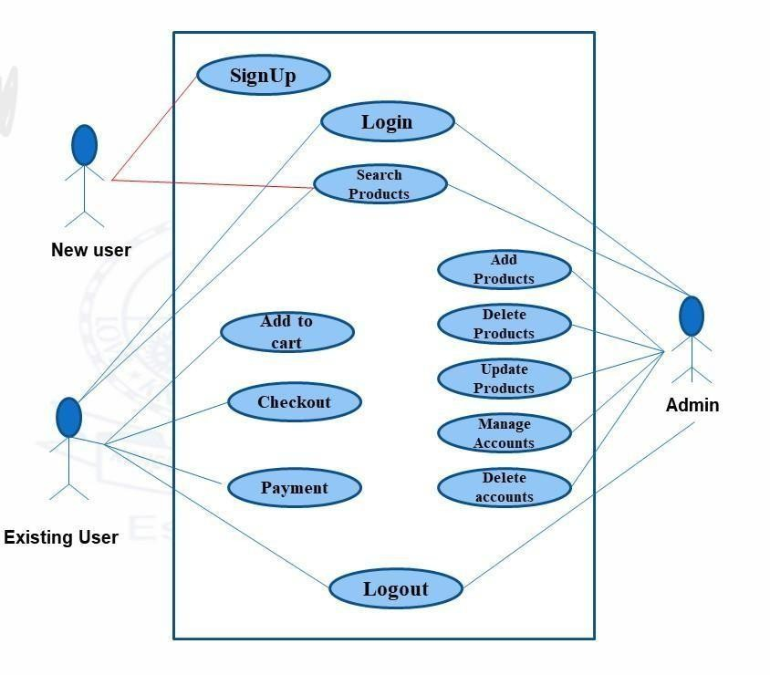

Figure 3.1 Use Case Diagram

3.2 CLASS DIAGRAM
A class diagram is a static structure diagram in UML (Unified Modeling Language) that illustrates the structure of the Luxe-Haven e-commerce system by showing the classes such as User, Product, Cart, Order, Wishlist, SupportTicket, and their attributes, methods, and relationships between them as shown in Figure 3.2. Classes represent the blueprint for objects, encapsulating data and behavior. This diagram helps in understanding the data flow and dependencies within the multi-role platform.
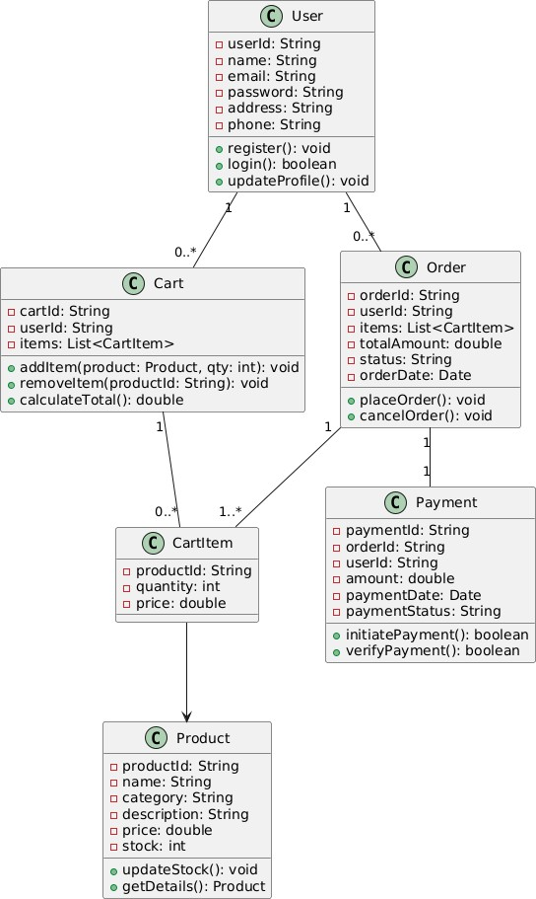

Figure 3.2 Class Diagram

3.3 SEQUENCE DIAGRAM
A sequence diagram is a form of interaction diagram which shows objects as lifelines running down the page, with their interactions over time represented as messages drawn as arrows from the source lifeline to the target lifeline. Sequence diagrams are good at showing which objects communicate with which other objects and what messages trigger those communications in the Luxe-Haven e-commerce system as shown below in Figure 3.3. Sequence diagrams are not intended for showing complex procedural logic.

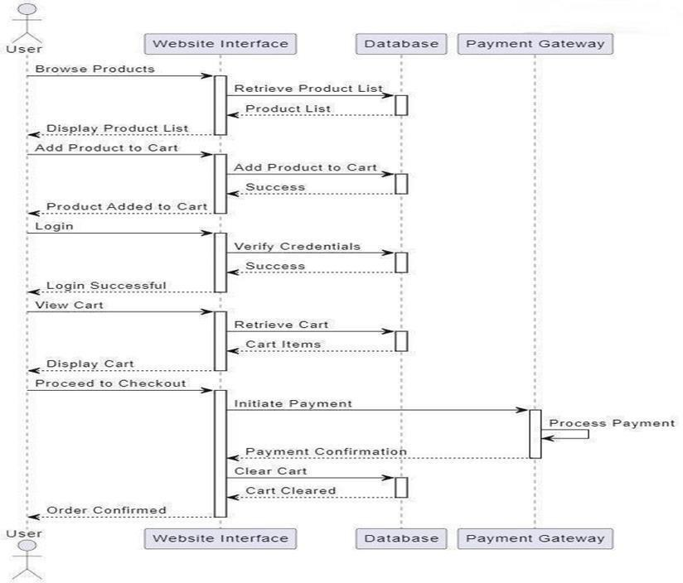

Figure 3.3 Sequence Diagram

3.4. ACTIVITY DIAGRAM
In UML, the activity diagram is used to demonstrate the flow of control within the Luxe-Haven e-commerce system rather than the implementation. It models the concurrent and sequential activities such as user registration, product browsing, adding items to cart, order placement, payment processing, and support ticket management. These structures are instrumental in visualizing complex business processes and ensuring proper synchronization of activities as shown in Figure 3.4 below.

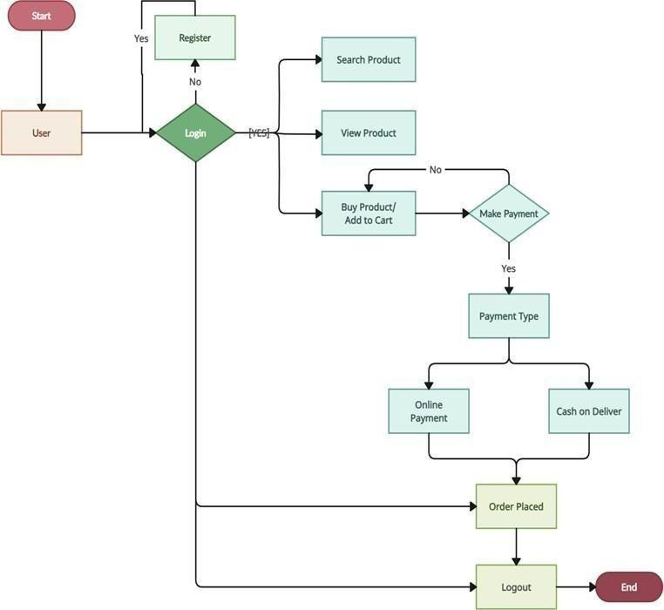

Figure 3.4 Activity Diagram

3.5 DATABASE DESIGN
Product Schema

const ProductSchema = new mongoose.Schema({
name: String,
description: String,
price: Number,
brand: String,
category: String,
stockQuantity: Number,
images: [String],
sellerId: { type: mongoose.Schema.Types.ObjectId, ref: 'User' }
});

const Product = mongoose.model('Product', ProductSchema);

User Schema
const UserSchema = new mongoose.Schema({
name: String,
email: String,
phone: String,
address: {
street: String,
city: String,
state: String,
pincode: String,
country: String
},
password: String,
profileImage: String,
role: { type: String, enum: ['buyer', 'seller', 'admin'], default: 'buyer' }
});

const User = mongoose.model('User', UserSchema);

Wishlist Item Schema

const WishlistSchema = new mongoose.Schema({
userId: { type: mongoose.Schema.Types.ObjectId, ref: 'User', required: true },
productId: { type: mongoose.Schema.Types.ObjectId, ref: 'Product', required: true }
});

const Wishlist = mongoose.model('Wishlist', WishlistSchema);

Cart Item Schema

const CartItemSchema = new mongoose.Schema({ userId: { type: String, required: true },
productId: { type: mongoose.Schema.Types.ObjectId, ref: 'Product', required: true }, quantity: { type: Number, required: true, min: 1 }, addedAt: { type: Date, default: Date.now }
});
const Cart = mongoose.model("CartItem", CartItemSchema, "cart-items");

Order Schema
OrderSchema = new mongoose.Schema({
userId: { type: mongoose.Schema.Types.ObjectId, ref: 'User', required: true },
items: [{
productId: { type: mongoose.Schema.Types.ObjectId, ref: 'Product', required: true },
quantity: { type: Number, required: true },
price: { type: Number, required: true }
}],
totalAmount: Number,
status: { type: String, enum: ['Placed', 'Confirmed', 'Shipped', 'Delivered', 'Cancelled'], default: 'Placed' },
paymentMode: { type: String, enum: ['COD', 'Card', 'UPI', 'Net Banking'] }
});

const Order = mongoose.model('Order', OrderSchema);

3.6 MODULES DESCRIPTION

3.6.1 User Authentication Module
This module handles user registration, login, and account management for the Luxe-Haven e-commerce platform. New users can sign up by providing credentials such as name, email, phone number, and password, which are securely hashed using bcryptjs and stored in MongoDB. The login system verifies credentials and issues JWT tokens for authenticated access to core features. Role-based access distinguishes between buyers, sellers, and admins, with additional security measures like login attempt limits and account locking. Profile management includes image uploads and updates, while future enhancements may include password reset and OTP verification for enhanced security.

3.6.2 Product Management Module
This module enables admins and sellers to manage the product inventory in the Luxe-Haven store. Products can be added, updated, or deleted through an intuitive interface, with attributes including name, description, price, size options, stock quantity, and images. Built with Node.js and Express, the backend APIs perform CRUD operations efficiently, ensuring real-time synchronization with MongoDB. Sellers can manage their own products, while admins oversee the entire catalog. The module includes stock tracking and automatic notifications when items run low, supporting scalable inventory management for the multi-seller marketplace.

3.6.3 Product Browsing and Search Module

This customer-facing module allows users to browse and search through available products in the Luxe-Haven platform. Products are organized by categories with detailed views including specifications, pricing, and availability. The search functionality enables quick filtering by name, category, or other attributes. Powered by React components and Axios for API calls, it fetches real-time data from the backend and displays it in a responsive UI. This module enhances user experience by providing clear product information, supporting informed purchasing decisions in the e-commerce environment.

3.6.4 Cart and Order Placement Module
This module facilitates shopping cart management and order processing in the Luxe-Haven application. Users can add products to their cart, adjust quantities, and remove items while viewing dynamic pricing calculations. Stock validation prevents overselling, and the module supports quantity-based discounts (tiered at 0-5 units: 0%, 6-10: 5%, 11+: 15%). Upon checkout, orders are processed through Express APIs, deducting stock and storing order data in MongoDB. Cart persistence allows users to resume sessions, while order previews reduce abandonment and build trust in the platform.

3.6.5 Support Module
This module offers customer support functionality for the Luxe-Haven platform, allowing users to create and track support tickets for product or order issues. Tickets can include file attachments (up to 5 files) and are managed through status tracking (open, in progress, resolved). The backend handles ticket creation and updates via Express routes, storing data in MongoDB. This module ensures responsive customer service, with uploads managed through Multer and notifications potentially sent via Nodemailer for improved user satisfaction.

3.6.6 Admin Dashboard Module
This administrative module provides system-wide oversight for the Luxe-Haven e-commerce platform. Admins can view comprehensive dashboards with order statistics, user management, and product oversight. The module includes tools for creating seller accounts, managing discount configurations, and monitoring stock history across the platform. Built with React components and secured API endpoints, it enables efficient platform administration, ensuring smooth operations and data integrity through role-based access controls.
3.6.7 Stock History Module
This module maintains an audit trail of inventory changes across the Luxe-Haven platform. It tracks stock additions, reductions, and updates for all products, providing transparency for admins and sellers. The module supports historical analysis and automated notifications when stock levels fall below thresholds. Implemented with MongoDB for scalable storage and Express APIs for data retrieval, it ensures accurate inventory management and helps prevent stockouts in the e-commerce operations.
CHAPTER 4

TESTING

4.1 SYSTEM TESTING
System testing is a comprehensive evaluation conducted to ensure that the complete and integrated system meets the defined requirements. In the Luxe-Haven e-commerce application, system testing encompassed core functionalities such as user registration, login authentication, product management, cart operations, order processing, wishlist management, and support ticket handling. Each module was rigorously tested under varied conditions to validate that all components interact seamlessly. Emphasis was placed on the end-to-end user flow, from user signup and product browsing to completing transactions and managing support requests. The testing ensured that UI responsiveness, backend communication, data consistency with MongoDB, and role-based access controls (buyer, seller, admin) all worked harmoniously. The primary goal was to confirm that the application delivers a stable, intuitive, and error-free experience aligned with multi-user e-commerce expectations.

4.2 UNIT TESTING
Unit testing is the first level of testing and focuses on testing individual components or functions in isolation. In the Luxe-Haven E-commerce App, unit tests were created for both frontend and backend elements. React components such as buttons, forms, input fields, product cards, and dashboard widgets were tested to ensure they render correctly and respond appropriately to user actions like clicks, form submissions, and navigation. The logic behind cart updates, quantity validations, and authentication checks was verified using mock data. These tests helped catch logical errors, improper state updates, and unexpected responses early in the development cycle, ensuring code reliability and easier debugging.

4.3 MODULE TESTING
Module testing was conducted to assess the performance and correctness of grouped functionalities within the application. Each module was treated as a separate functional unit and tested for internal consistency. For instance, the Authentication Module was tested for signup, login, session handling, and role assignment; the Product Management Module was evaluated for adding, editing, deleting, and viewing products with image uploads; the Cart Module was tested for managing items and quantity limits; the Order Module was checked for processing purchases and applying discounts; the Wishlist Module was verified for saving and removing favorites; and the Support Module was assessed for ticket creation and file attachments

4.4 INTEGRATION TESTING
Integration testing involved testing the interaction between different modules and services of the application. It validated whether modules like authentication, product management, cart, orders, and support communicate and function correctly when integrated. For example, after a user logs in, the JWT token should allow access to personalized dashboards, and subsequent actions like adding items to cart, placing orders, and creating support tickets should reflect accurately in the backend. API calls made from the React frontend to Express.js backend routes were tested to verify correct responses, error handling, and data synchronization with MongoDB. Integration with third-party services like email notifications via Nodemailer and file uploads via Multer was tested for scenarios such as attachment handling and notification triggers.

4.5 VALIDATION TESTING
Validation testing confirmed that the final software product met all defined functional and non-functional requirements. The application was validated against original business goals: secure user authentication with role-based access, efficient product catalog management, intuitive cart and order processing with discount tiers, wishlist functionality, and responsive support system. It included field validation for form inputs, stock quantity limits, password strength, and JWT token verification. Error scenarios were tested thoroughly, such as invalid login credentials, network connectivity issues during checkout, file upload failures, and database connection problems. The app was also validated for UI responsiveness across different devices and browsers, ensuring accessibility for buyers, sellers, and admins. This phase ensured that the entire app functions correctly under realistic conditions, fulfilling both technical and user-centric goals for the multi-role e-commerce platform.
CHAPTER 5

RESULTS AND DISCUSSION

The Luxe-Haven E-Commerce App developed for modern retail operations has effectively delivered a comprehensive web-based solution for managing multi-seller product sales and user interactions. It allows users to easily register, log in, explore a diverse range of products with detailed specifications, add items to their cart, manage wishlists, and securely complete purchases with integrated order processing. The backend, powered by Node.js and Express.js, works seamlessly with MongoDB to handle data operations like product listings, user management, order tracking, and support ticket handling in real time. Built using React with Vite, the app offers a consistent and responsive user experience across devices through its clean interface and intuitive navigation, encouraging repeat usage. Role-based functionalities enable buyers to browse and purchase, sellers to manage inventory and track sales, and admins to oversee operations, order status updates, and system configurations, reducing manual work and improving efficiency. Extensive testing confirmed smooth performance, quick response times, and reliable data synchronization. The app enhances customer engagement through features like stock history tracking, quantity-based discounts, and personalized dashboards, fostering loyalty in a competitive market. In terms of long-term value, the application is built with scalability in mind, allowing future enhancements like advanced analytics, payment gateway integrations, multilingual support, and expanded reporting. Overall, the app represents a modern, digital-first approach to e-commerce, aligning with growth objectives and setting the foundation for continued expansion in the online retail domain.

Figure 5.1 HOME SCREEN
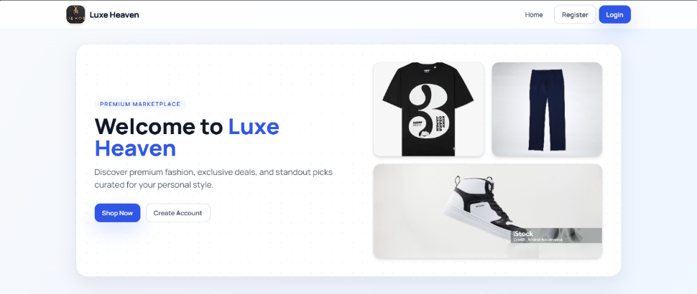

The Home Screen is the main landing page of the system where users get an overview of the company and its purpose.

Figure 5.2 ITEM ADDED TO THE CART
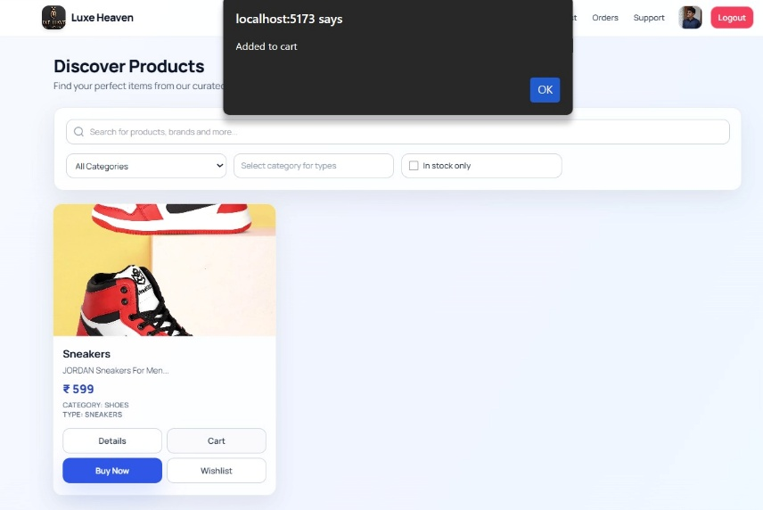

This image illustrates that the item has been successfully added to your cart. You can continue shopping or proceed to checkout to complete your purchase.

Figure 5.3 WISHLIST SCREEN

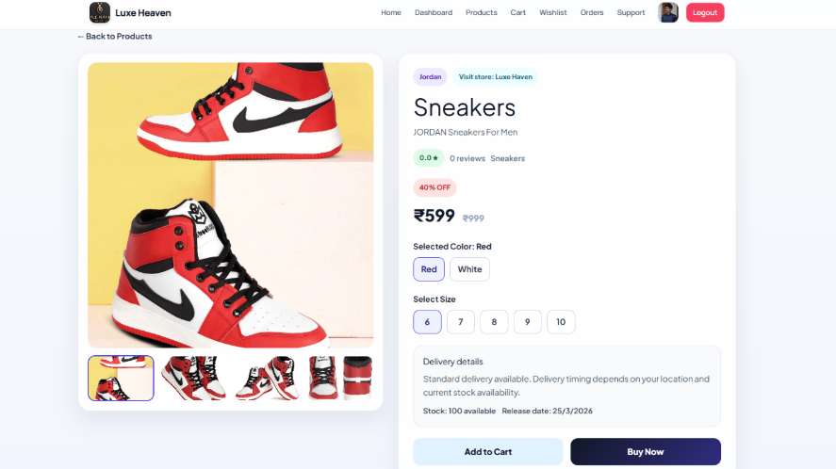

This image illustrates the items that has been added to the wishlist of the customer

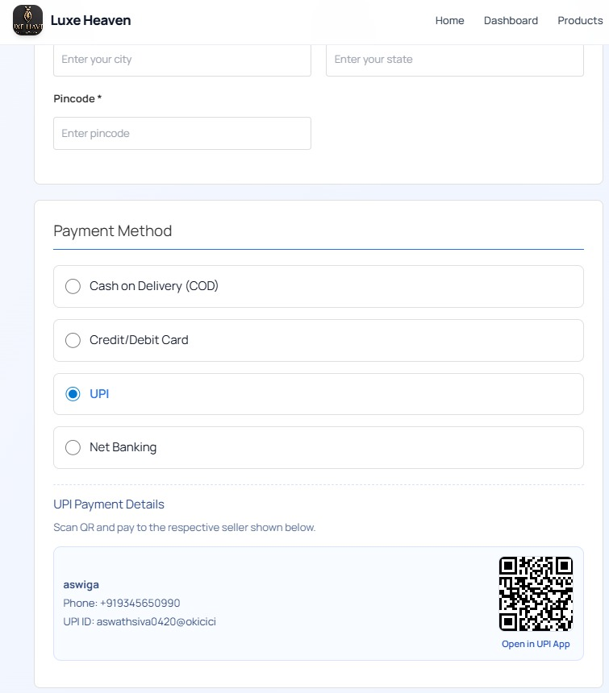
Figure 5.4 PAYMENT SCREEN

The Payment Screen allows users to review their order details and choose a preferred payment method. It ensures a secure transaction process to complete the purchase successfully.
CHAPTER 6

CONCLUSION AND FUTURE WORK
The Luxe-Haven E-Commerce App has achieved its core purpose of creating a user-friendly, scalable, and efficient multi-seller marketplace platform that simplifies the process of buying and selling diverse products online. By incorporating modern technologies such as React with Vite for a responsive frontend interface, Node.js and Express.js for robust server-side operations, and MongoDB for flexible database management, the app ensures high performance and seamless functionality across all user roles. It streamlines the customer journey from product discovery and wishlist management to secure cart operations and order placement, while also empowering sellers with convenient inventory management tools and admins with comprehensive system oversight and configuration controls.
The app's deployment has significantly improved business efficiency by reducing manual intervention through automated order processing, minimizing errors via validation mechanisms, and increasing customer accessibility to a diverse product catalog. It bridges the gap between traditional retail and modern e-commerce, positioning the platform for digital growth and expanded market reach across multiple seller communities.
Looking toward the future, there is substantial potential to incorporate additional features such as AI-based product recommendation engines, advanced order tracking and shipment integration with logistics providers, and comprehensive sales analytics dashboards for sellers and admins. Multi-language and multi-currency support can cater to regional and international audiences, while implementing a robust rating and review system will build trust and transparency among buyers. Furthermore, integrating real-time customer chat support, predictive inventory analytics, social commerce integration, and advanced seller subscription tiers can expand the platform's usability and revenue streams. Mobile app development using React Native would extend accessibility to smartphone users. These enhancements will strengthen customer relationships, drive seller engagement, and support the long-term scalability and adaptability of the application in an evolving digital marketplace, ultimately positioning Luxe-Haven as a leading e-commerce platform.
APPENDIX 1
CODING
App.jsx
import { BrowserRouter, Routes, Route, useLocation } from "react-router-dom";
import Navbar from "./components/Navbar";
import { AnimatePresence, motion } from "framer-motion";

import Home from "./pages/Home";
import Login from "./pages/Login";
import Register from "./pages/Register";
import Products from "./pages/Products";
import ProductDetails from "./pages/ProductDetails";
import Cart from "./pages/Cart";
import Wishlist from "./pages/Wishlist";
import Checkout from "./pages/Checkout";
import Orders from "./pages/Orders";
import BuyerDashboard from "./pages/BuyerDashboard";
import SellerDashboard from "./pages/SellerDashboard";
import SellerProductManagement from "./pages/SellerProductManagement";
import SellerOrderManagement from "./pages/SellerOrderManagement";
import StockHistory from "./pages/StockHistory";
import AdminDashboard from "./pages/AdminDashboard";
import Support from "./pages/Support";
import Profile from "./pages/Profile";

const pageVariants = {
initial: {
opacity: 0,
y: 16,
filter: "blur(6px)",
},
animate: {
opacity: 1,
y: 0,
filter: "blur(0px)",
transition: { duration: 0.4, ease: "easeOut" },
},
exit: {
opacity: 0,
y: -16,
filter: "blur(4px)",
transition: { duration: 0.25, ease: "easeIn" },
},
};

function AnimatedRoutes() {
const location = useLocation();

return (
<AnimatePresence mode="wait">
<motion.div
key={location.pathname}
variants={pageVariants}
initial="initial"
animate="animate"
exit="exit"
>
<Routes location={location}>
<Route path="/" element={<Home />} />
<Route path="/login" element={<Login />} />
<Route path="/register" element={<Register />} />

<Route path="/products" element={<Products />} />
<Route path="/products/:id" element={<ProductDetails />} />
<Route path="/cart" element={<Cart />} />
<Route path="/wishlist" element={<Wishlist />} />
<Route path="/checkout" element={<Checkout />} />
<Route path="/orders" element={<Orders />} />
<Route path="/support" element={<Support />} />
<Route path="/profile" element={<Profile />} />

<Route path="/buyer/dashboard" element={<BuyerDashboard />} />
<Route path="/seller/dashboard" element={<SellerDashboard />} />
<Route path="/seller/products" element={<SellerProductManagement />} />
<Route path="/seller/orders" element={<SellerOrderManagement />} />
<Route path="/seller/stock-history" element={<StockHistory />} />
<Route path="/admin" element={<AdminDashboard />} />
</Routes>
</motion.div>
</AnimatePresence>
}

export default function App() {
return (
<BrowserRouter>
<div className="app-shell">
<Navbar />
<AnimatedRoutes />
</BrowserRouter>
);
}

Home.jsx:
import { useNavigate } from "react-router-dom";
import { motion } from "framer-motion";
import tshirtImage from "../assets/tshirt.avif";
import pantImage from "../assets/pant.jpg";
import sneakersImage from "../assets/sneakers.jpg";

const heroVariants = {
hidden: { opacity: 0, y: 24 },
visible: {
opacity: 1,
y: 0,
transition: { duration: 0.6, ease: "easeOut" },
},
};

const featureCardVariants = {
hidden: { opacity: 0, y: 20 },
visible: (index) => ({
opacity: 1,
y: 0,
transition: { duration: 0.4, delay: index * 0.08, ease: "easeOut" },
}),
};

export default function Home() {
const navigate = useNavigate();
const role = localStorage.getItem("role");

const handleShopNow = () => {
if (role) {
// If logged in, go to products
navigate("/products");
} else {
// If not logged in, go to login
navigate("/login");
}
};

return (
<div className="mx-auto w-full max-w-[1240px] px-4 pb-16 pt-8 md:px-8">
<motion.section
className="relative overflow-hidden rounded-3xl border border-brand-200/70 bg-white p-6 shadow-card md:p-10"
variants={heroVariants}
initial="hidden"
animate="visible"
>
<div className="pointer-events-none absolute inset-0 bg-hero-grid bg-[size:22px_22px] opacity-50" />
<div className="relative grid items-center gap-8 lg:grid-cols-[1.15fr_1fr]">
<div>
<p className="mb-3 inline-flex rounded-full bg-brand-50 px-3 py-1 text-xs font-semibold uppercase tracking-[0.14em] text-brand-700">
Premium Marketplace
</p>
<h1 className="text-3xl font-extrabold leading-tight text-slate-900 md:text-5xl">
Welcome to <span className="text-brand-600">Luxe Haven</span>
</h1>
<p className="mt-4 max-w-xl text-base text-slate-600 md:text-lg">
Discover premium fashion, exclusive deals, and standout picks curated for your personal style.
</p>
<div className="mt-7 flex flex-wrap gap-3">
<button className="ui-btn-primary" onClick={handleShopNow}>Shop Now</button>
{!role && (
<button className="ui-btn-soft" onClick={() => navigate("/register")}>Create Account</button>
)}
</div>
</div>

<div className="grid grid-cols-2 gap-3 sm:gap-4">
{[tshirtImage, pantImage, sneakersImage].map((img, i) => (
<motion.div
key={img}
initial={{ opacity: 0, y: 24 }}
animate={{ opacity: 1, y: 0 }}
transition={{ delay: i * 0.12 + 0.2, duration: 0.35 }}
className={`overflow-hidden rounded-2xl border border-slate-200 bg-slate-100 shadow-md ${i === 2 ? "col-span-2" : ""}`}
>
<img src={img} alt="Collection" className="h-44 w-full object-cover sm:h-52" />
</motion.div>
))}
</div>
</div>
</motion.section>

<section className="mt-10 grid gap-4 sm:grid-cols-2 lg:grid-cols-4">
{[
["🎯", "Wide Selection", "Thousands of products across categories"],
["💰", "Best Prices", "Exclusive deals and smart pricing"],
["🔒", "Secure Shopping", "Protected checkout and data safety"],
["⭐", "Top Rated", "Loved by repeat customers"],
].map(([icon, title, desc], index) => (
<motion.div
key={title}
className="glass-card p-5"
variants={featureCardVariants}
initial="hidden"
whileInView="visible"
viewport={{ once: true, amount: 0.3 }}
custom={index}
>
<div className="text-2xl">{icon}</div>
<h3 className="mt-2 text-lg font-bold text-slate-900">{title}</h3>
<p className="mt-1 text-sm text-slate-600">{desc}</p>
</motion.div>
))}
</section>

<section className="mt-12">
<h2 className="text-2xl font-extrabold text-slate-900">Shop by Category</h2>
<div className="mt-5 grid gap-4 sm:grid-cols-2 lg:grid-cols-4">
{[
["👔", "Men's Fashion", "Premium clothing", "Men"],
["👗", "Women's Fashion", "Elegant styles", "Women"],
["📱", "Electronics", "Latest gadgets", "Electronics"],
["🏠", "Home & Living", "Furniture and decor", "Home"],
].map(([icon, title, desc, cat]) => (
<motion.button
key={title}
whileHover={{ y: -6, scale: 1.01 }}
transition={{ type: "spring", stiffness: 250, damping: 22 }}
onClick={() => navigate(role ? `/products?category=${cat}` : "/login")}
className="glass-card group p-5 text-left"
>
<div className="text-2xl">{icon}</div>
<h3 className="mt-2 text-lg font-bold text-slate-900 group-hover:text-brand-700">{title}</h3>
<p className="text-sm text-slate-600">{desc}</p>
</motion.button>
))}
</div>
</section>

{!role && (
<motion.section
className="mt-12 rounded-3xl border border-brand-200 bg-gradient-to-r from-brand-600 to-brand-800 p-8 text-white shadow-card"
initial={{ opacity: 0, y: 18 }}
whileInView={{ opacity: 1, y: 0 }}
viewport={{ once: true, amount: 0.4 }}
transition={{ duration: 0.45 }}
>
<h2 className="text-2xl font-extrabold">Ready to Start Shopping?</h2>
<p className="mt-2 text-brand-100">Join thousands of happy customers and discover amazing products.</p>
<div className="mt-5 flex flex-wrap gap-3">
<button className="rounded-xl bg-white px-4 py-2.5 text-sm font-bold text-brand-700" onClick={() => navigate("/register")}>
Sign Up Free
</button>
<button className="rounded-xl border border-brand-300/60 bg-brand-700/40 px-4 py-2.5 text-sm font-bold text-white" onClick={() => navigate("/login")}>
Sign In
</button>
</div>
</motion.section>
)}
</div>
);
}

Products.jsx:
import { useEffect, useState } from "react";
import { useNavigate } from "react-router-dom";
import api from "../services/api";
import { motion } from "framer-motion";
import { buildUploadUrl } from "../utils/assetUrl";

const gridVariants = {
hidden: { opacity: 0 },
visible: {
opacity: 1,
transition: { staggerChildren: 0.04, delayChildren: 0.1 },
},
};

const cardVariants = {
hidden: { opacity: 0, y: 16 },
visible: {
opacity: 1,
y: 0,
transition: { duration: 0.3, ease: "easeOut" },
},
};

export default function Products() {
const [products, setProducts] = useState([]);
const [search, setSearch] = useState("");
const [category, setCategory] = useState("");
const [subCategory, setSubCategory] = useState("");
const [inStockOnly, setInStockOnly] = useState(false);
const navigate = useNavigate();
const token = localStorage.getItem("token");

const CATEGORY_OPTIONS = [
"",
"Tshirt",
"Pants",
"Shoes",
"Men",
"Women",
"Electronics",
"Home",
"Sports",
"Books",
"Toys",
"Accessories",
"Other",
];

const SUBCATEGORY_OPTIONS = {
Tshirt: ["Crew Neck", "V-Neck", "Polo", "Tank Top"],
Pants: ["Jeans", "Chinos", "Shorts", "Track Pants"],
Shoes: ["Sneakers", "Boots", "Sandals", "Loafers"]
};

useEffect(() => {
const controller = new AbortController();

const fetchProducts = async () => {
try {
const res = await api.get("/products", {
signal: controller.signal,
params: {
search: search || undefined,
category: category || undefined,
subCategory: subCategory || undefined,
inStock: inStockOnly ? "true" : undefined
}
});
setProducts(res.data);
} catch (err) {
if (err.name !== "CanceledError" && err.name !== "AbortError") {
console.error(err);
}
}
};

const timer = setTimeout(fetchProducts, 250);
return () => {
clearTimeout(timer);
controller.abort();
};
}, [search, category, subCategory, inStockOnly]);

const addToCart = async (id) => {
if (!token) {
alert("Please login to add items to cart");
navigate("/login");
return;
}
try {
await api.post("/cart/add", { productId: id });
alert("Added to cart");
} catch (error) {
console.error("Error adding to cart:", error);
alert(error.response?.data?.msg || "Error adding to cart");
}
};

const addToWishlist = async (id) => {
if (!token) {
alert("Please login to add items to wishlist");
navigate("/login");
return;
}
try {
await api.post("/wishlist/add", { productId: id });
alert("Added to wishlist");
} catch (error) {
console.error("Error adding to wishlist:", error);
alert(error.response?.data?.msg || "Error adding to wishlist");
}
};

const buyNow = (product) => {
if (!token) {
alert("Please login to buy");
navigate("/login");
return;
}
navigate("/checkout", {
state: {
items: [{
productId: product,
quantity: 1,
subtotal: product.price
}],
total: product.price,
fromCart: false
}
});
};

const openProductDetails = (id) => {
navigate(`/products/${id}`);
};

const role = localStorage.getItem("role");

return (
<div className="mx-auto w-full max-w-[1240px] px-4 pb-16 pt-8 md:px-8">
<div className="mb-6">
<h2 className="text-3xl font-extrabold tracking-tight text-slate-900">Discover Products</h2>
<p className="mt-1 text-slate-600">Find your perfect items from our curated collection.</p>
</div>

<div className="glass-card mb-8 p-4 md:p-5">
<div className="relative mb-4">
<input
type="text"
className="ui-input pl-10"
placeholder="Search for products, brands and more..."
value={search}
onChange={(e) => setSearch(e.target.value)}
/>
<svg className="pointer-events-none absolute left-3 top-1/2 h-5 w-5 -translate-y-1/2 text-slate-400" viewBox="0 0 24 24" fill="none" stroke="currentColor" strokeWidth="2">
<circle cx="11" cy="11" r="8"></circle>
<path d="m21 21-4.35-4.35"></path>
</svg>
</div>

<div className="grid gap-3 sm:grid-cols-2 lg:grid-cols-4">
<select
className="ui-input"
value={category}
onChange={(e) => {
setCategory(e.target.value);
setSubCategory("");
}}
>
<option value="">All Categories</option>
{CATEGORY_OPTIONS.filter((c) => c).map((cat) => (
<option key={cat} value={cat}>{cat}</option>
))}
</select>

{SUBCATEGORY_OPTIONS[category] ? (
<select className="ui-input" value={subCategory} onChange={(e) => setSubCategory(e.target.value)}>
<option value="">All Types</option>
{SUBCATEGORY_OPTIONS[category].map((type) => (
<option key={type} value={type}>{type}</option>
))}
</select>
) : (
<div className="ui-input flex items-center text-slate-400">Select category for types</div>
)}

<label className="flex items-center gap-2 rounded-xl border border-slate-300 bg-white px-3 py-2.5 text-sm font-medium text-slate-700">
<input
type="checkbox"
checked={inStockOnly}
onChange={(e) => setInStockOnly(e.target.checked)}
className="h-4 w-4 rounded border-slate-300"
/>
In stock only
</label>
</div>
</div>

{products.length === 0 ? (
<div className="glass-card p-8 text-center text-slate-600">No products available yet. Check back later.</div>
) : (
<motion.div className="grid gap-5 sm:grid-cols-2 lg:grid-cols-3" variants={gridVariants} initial="hidden" animate="visible">
{products.map((p) => (
<motion.div
className="glass-card cursor-pointer"
key={p._id}
variants={cardVariants}
whileHover={{ y: -8, scale: 1.01 }}
transition={{ type: "spring", stiffness: 260, damping: 22 }}
onClick={() => openProductDetails(p._id)}
role="button"
tabIndex={0}
onKeyDown={(e) => {
if (e.key === "Enter" || e.key === " ") {
e.preventDefault();
openProductDetails(p._id);
}
}}
>
<div className="h-56 overflow-hidden rounded-t-2xl bg-slate-100">
<img
src={buildUploadUrl(`uploads/${p.image}`)}
alt={p.name}
className="h-full w-full object-cover"
onError={(e) => {
e.target.src = "https://via.placeholder.com/300x300?text=No+Image";
}}
/>
</div>

<div className="p-4">
<h4 className="text-lg font-bold text-slate-900">{p.name}</h4>
<p className="mt-1 text-sm text-slate-600">{p.description?.substring(0, 70)}...</p>
<p className="mt-2 text-xl font-extrabold text-brand-700">₹ {p.price}</p>
{p.category && <p className="mt-1 text-xs font-semibold uppercase tracking-wide text-slate-500">Category: {p.category}</p>}
{p.subCategory && <p className="text-xs font-semibold uppercase tracking-wide text-slate-500">Type: {p.subCategory}</p>}

{p.stockQuantity <= 0 && (
<div className="mt-2 inline-flex rounded-full bg-rose-100 px-3 py-1 text-xs font-bold text-rose-700">Out of stock</div>
)}
{p.stockQuantity > 0 && p.stockQuantity < 5 && (
<div className="mt-2 inline-flex rounded-full bg-amber-100 px-3 py-1 text-xs font-bold text-amber-700">Only {p.stockQuantity} left</div>
)}

{role === "buyer" || role === "user" || !role ? (
<div className="mt-4 grid grid-cols-2 gap-2 pb-1">
<button
className="ui-btn-soft w-full px-2"
onClick={(e) => {
e.stopPropagation();
openProductDetails(p._id);
}}
title="View Details"
>
Details
</button>

<button
className="ui-btn-soft w-full px-2"
onClick={(e) => {
e.stopPropagation();
addToCart(p._id);
}}
disabled={p.stockQuantity <= 0}
title="Add to Cart"
>
Cart
</button>

<button
className="ui-btn-primary w-full px-2"
onClick={(e) => {
e.stopPropagation();
buyNow(p);
}}
disabled={p.stockQuantity <= 0}
title="Buy Now"
>
Buy Now
</button>

<button
className="ui-btn-soft w-full px-2"
onClick={(e) => {
e.stopPropagation();
addToWishlist(p._id);
}}
disabled={p.stockQuantity <= 0}
title="Add to Wishlist"
>
Wishlist
</button>
</div>
) : (
<div className="mt-4 inline-flex rounded-full bg-slate-100 px-3 py-1 text-xs font-semibold text-slate-500">View only</div>
)}
</div>
</motion.div>
))}
</motion.div>
)}
</div>
);
}

APPENDIX 2
SNAPSHOTS

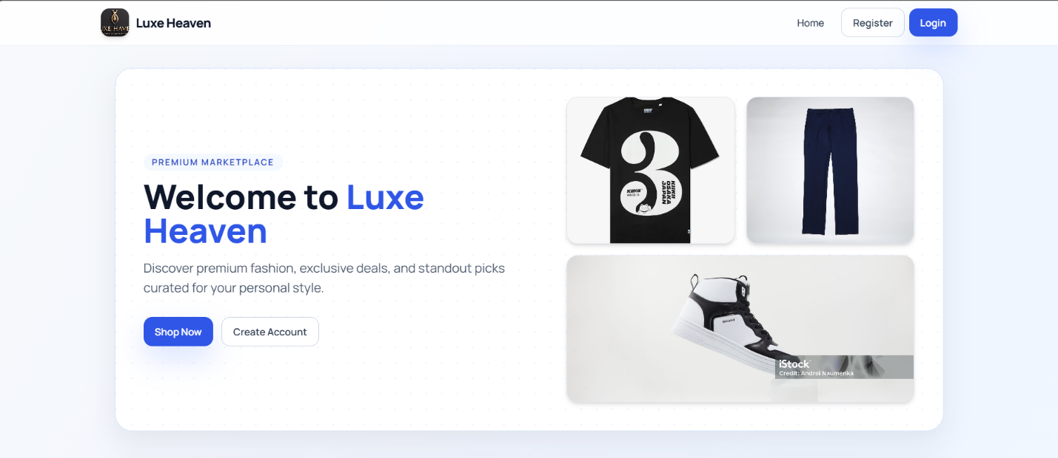

Figure. A2.1 Home page
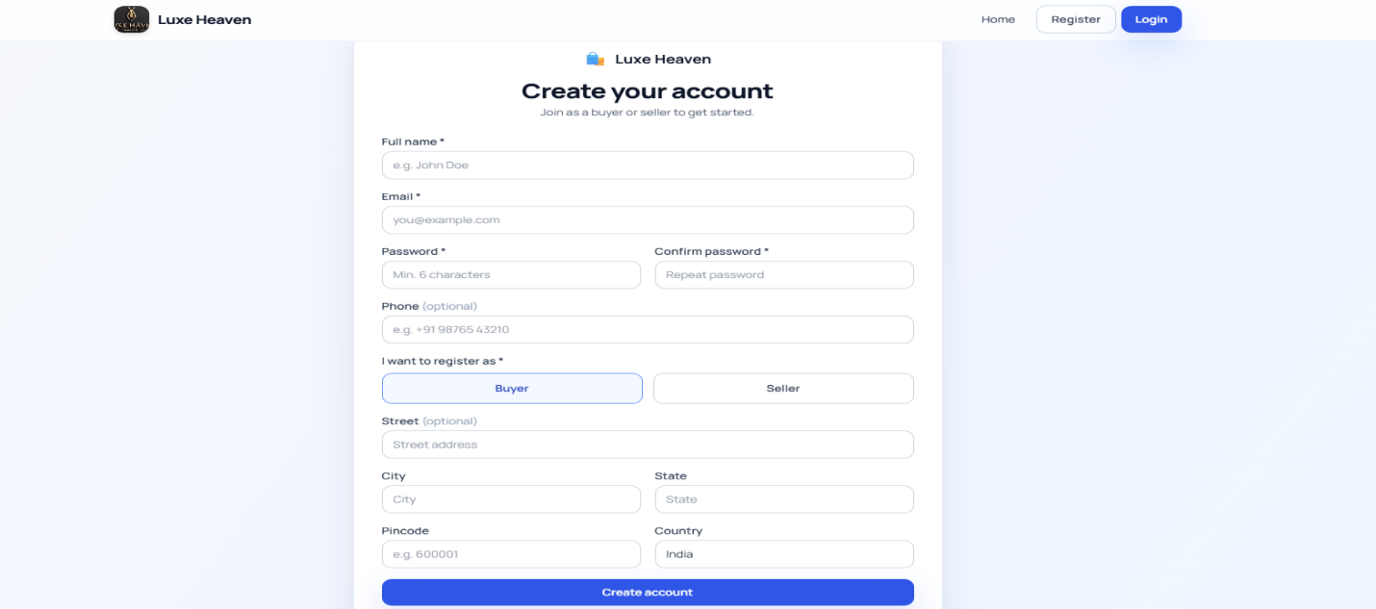

Figure. A2.2 Register Screen

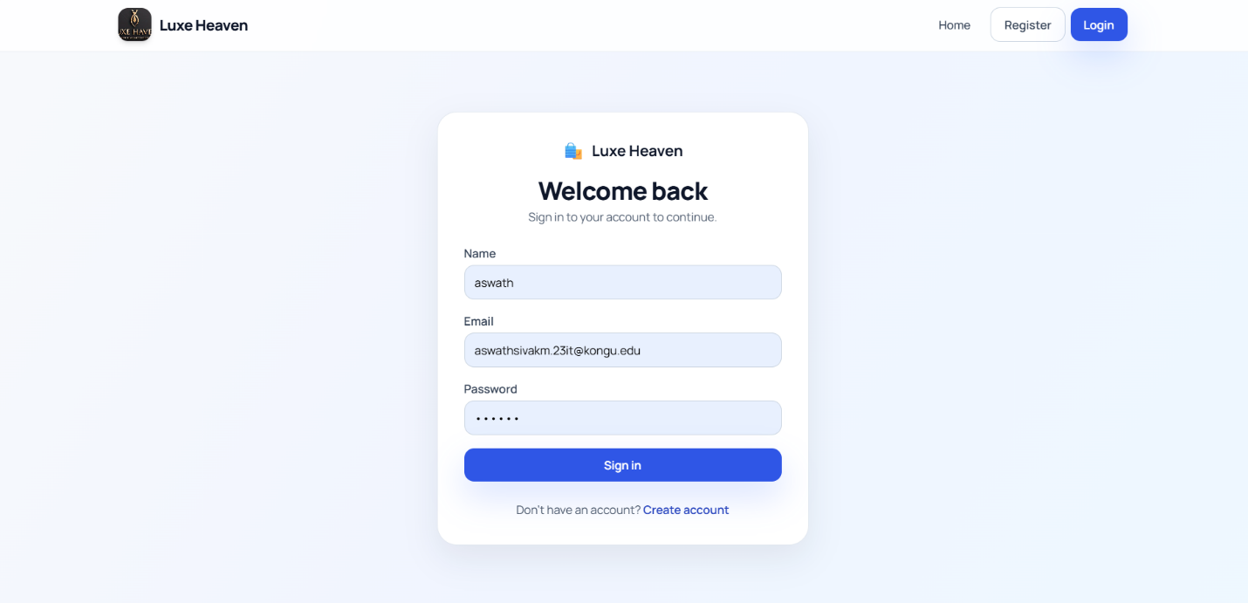

Figure. A2.3 Login Screen

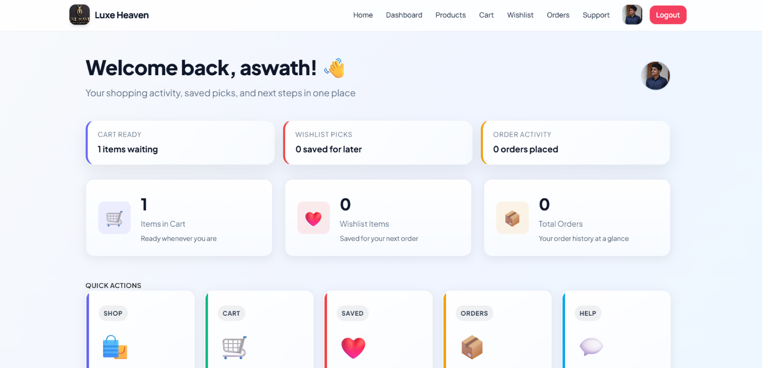

Figure. A2.4 User Dashboard

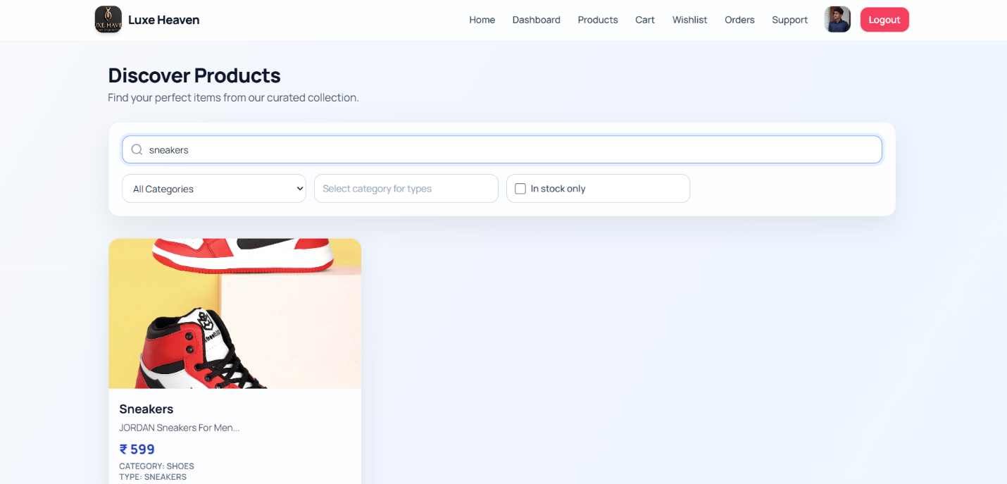

Figure. A2.5 Product Listing

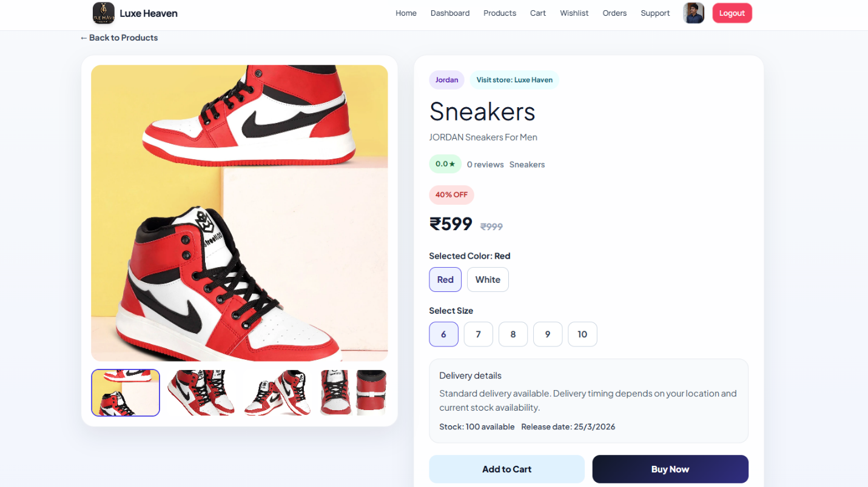

Figure. A2.6 Product Details
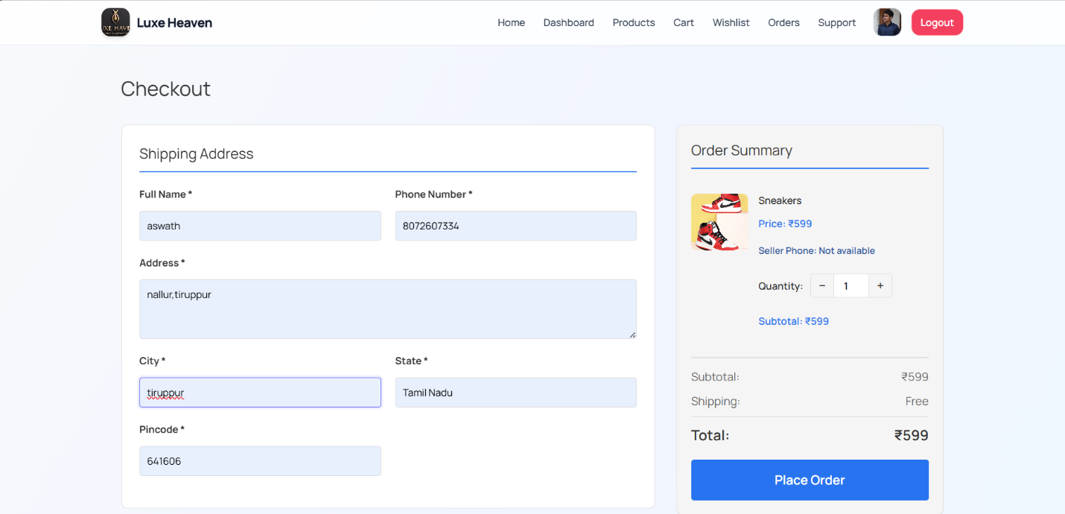

Figure. A2.7 Shipping Details of User

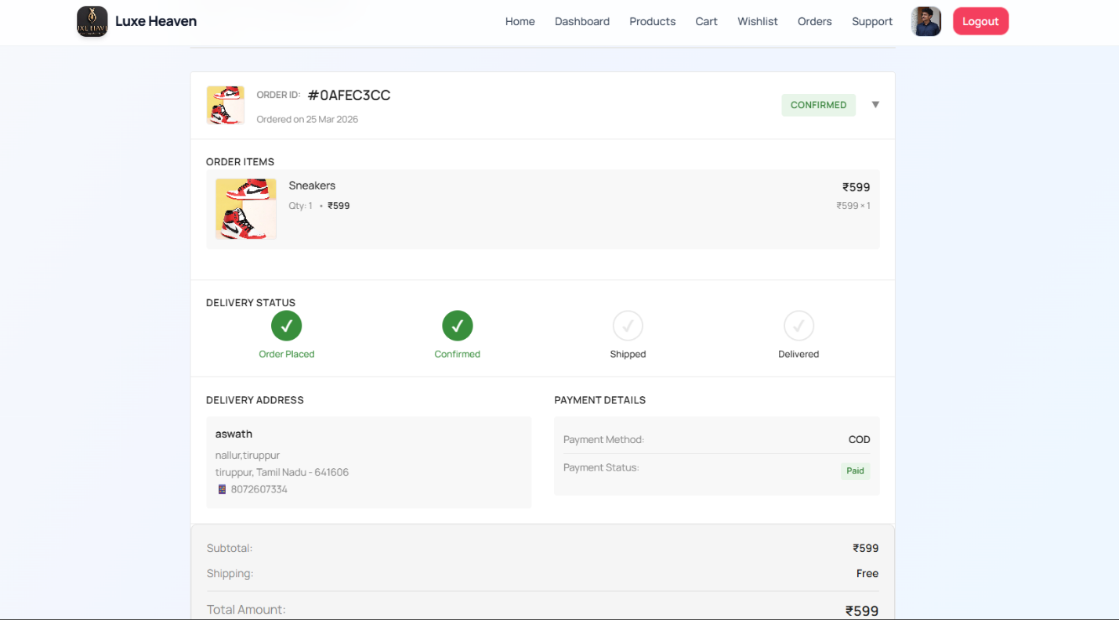

Figure. A2.8 User’s Orders

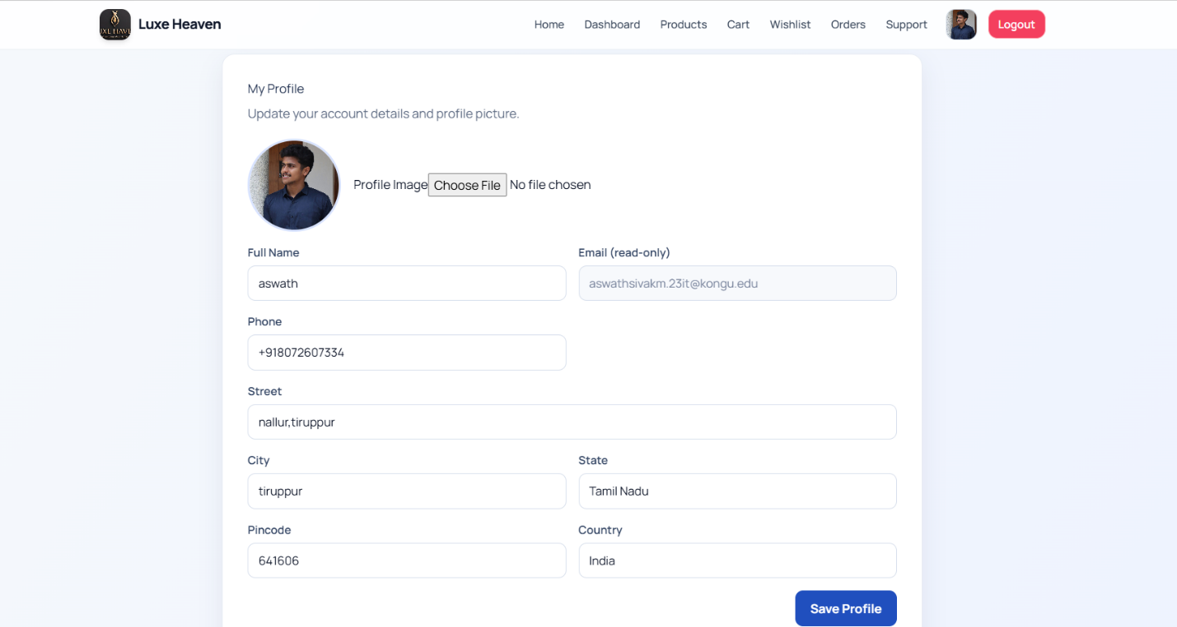
Figure. A2.9 User Profile page
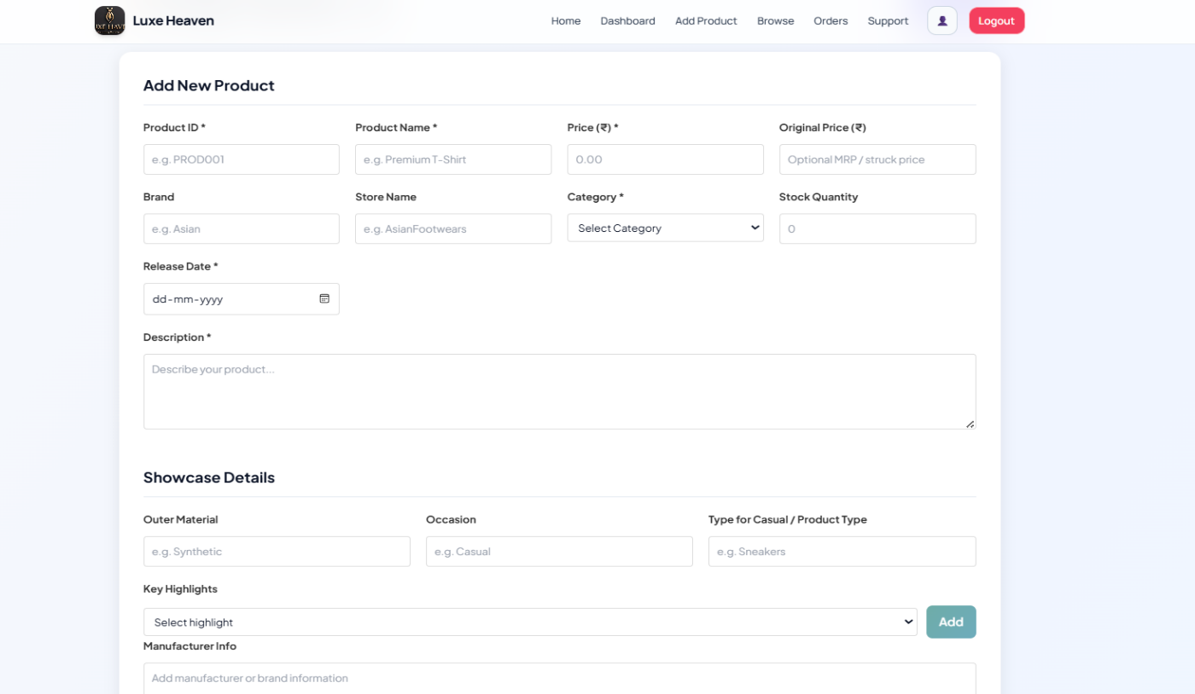

Figure. A2.10 Seller - Add Product

REFERENCES

    - React Documentation - Meta (Facebook), https://react.dev/
    - Vite Documentation - Vite Team, https://vitejs.dev/
    - Tailwind CSS Documentation - Tailwind Labs, https://tailwindcss.com/docs
    - Framer Motion Documentation - Framer, https://www.framer.com/motion/
    - Axios Documentation - Axios, https://axios-http.com/docs/
    - React Router DOM Documentation - React Training, https://reactrouter.com/
    - QRCode.react Documentation - zpao, https://github.com/zpao/qrcode.react
    - Node.js Documentation - OpenJS Foundation, https://nodejs.org/en/docs
    - Express.js Guide - Express.js Official Site, https://expressjs.com/
    - MongoDB Manual - MongoDB Inc., https://www.mongodb.com/docs/manual/
    - Github Link:https://github.com/AswathSiva2005/Luxe-Haven
    - Github Link:https://github.com/ASWIGA/luxe-Haven.git

APPROVAL LETTER FROM THE COMPANY
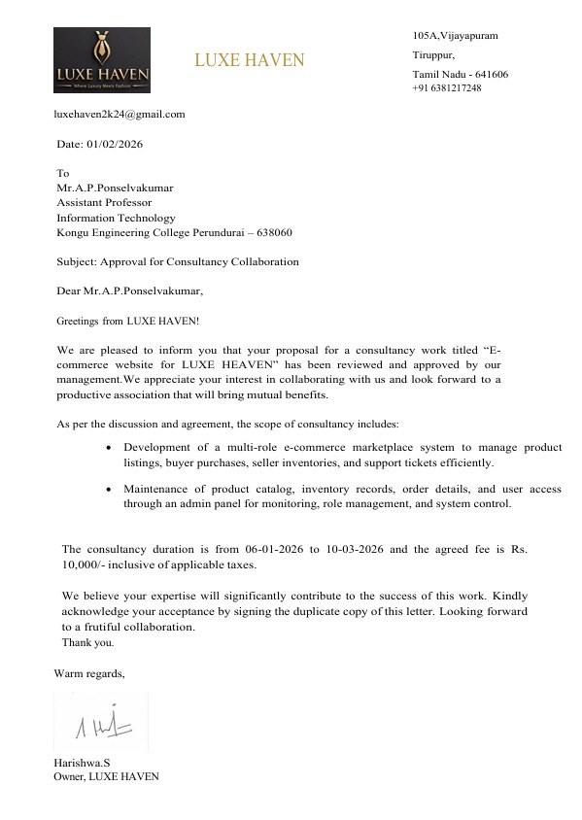

COMPLETION LETTER FROM THE COMPANY
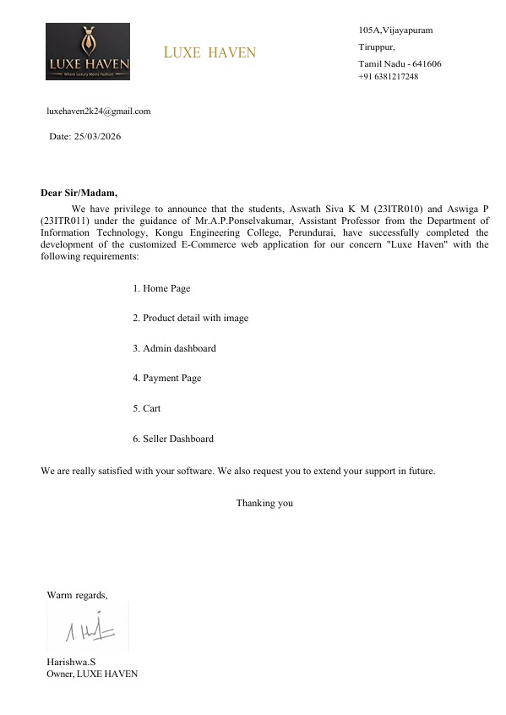

RECEIPT
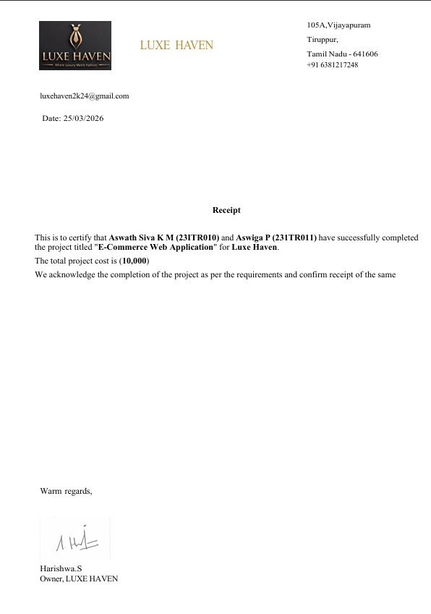

MAPPING OF SDG TO PROJECT WORK-I

Sustainable Development Goals (SDGs) are a set of global goals established by the United Nations to promote sustainable development and improve the quality of life for people around the world. They focus on important areas such as economic growth, environmental protection, innovation, education, and social equality. By integrating sustainable practices and technologies, different sectors—including digital platforms like e-commerce—can contribute to achieving these goals and creating a better and more sustainable future for society.

SDG 9 – Industry, Innovation and Infrastructure
This project aligns with SDG Goal 9 by introducing digital innovation into the traditional retail and e-commerce industry. The Luxe-Haven e-commerce platform modernizes the online shopping experience by enabling customers to browse diverse products, manage wishlists, place orders, and make secure payments through integrated payment gateways. By transforming conventional retail into a technology-driven multi-seller marketplace, the project promotes industrial innovation and improves digital infrastructure for efficient trade and commerce.
Additionally, the system strengthens business operations through features such as real-time inventory management via stock history tracking, seller dashboards for product management, order fulfillment workflows, and comprehensive admin systems for monitoring sales, customer activities, and platform configuration. These digital tools enhance operational efficiency, reduce manual processes, support scalable growth, and enable small sellers to compete in the digital marketplace. By integrating modern digital infrastructure into online retail operations, the project contributes to building resilient industry systems across multiple seller communities and encourages technological adoption in traditional commerce sectors. The platform's use of contemporary technologies—React, Node.js, MongoDB, and cloud-based architecture—demonstrates commitment to digital transformation and infrastructure modernization, which are core objectives of Sustainable Development Goal 9.

